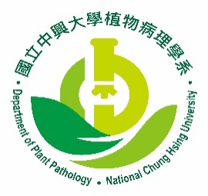 | 農業暨自然資源學院 植物病理學系 402台中市興大路145號  NATIONAL CHUNG HSING UNIVERSITY  _{COLLEGE OF AGRICULTURE}  _{DEPARTMENT OF PLANT PATHOLOGY} | 145 XINGDA ROAD, TAICHUNG  TAIWAN 402, REPUBLIC OF CHINA  TEL: 886-4-22840780-2 FAX:886-4-22877585  E-mail:plantp@nchu.edu.tw http://www.pp.nchu.edu.tw

